**Art Elements**

**Line** - an actual or implied mark, path, mass, or edge, where length is dominant

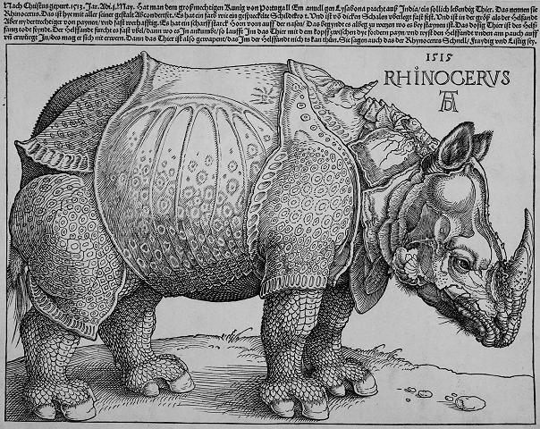 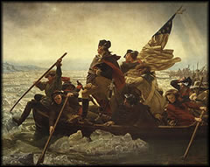

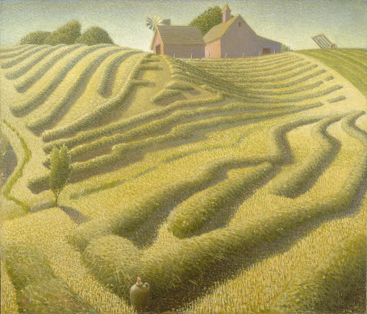

**Texture** - the way a surface appears or feels when touched (rough, smooth, etc.) implied vs actual

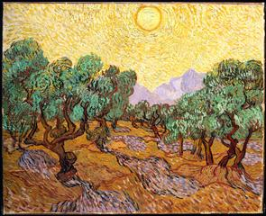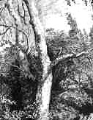

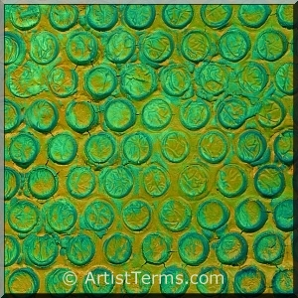

**Value** - the degree of lightness or darkness of a given color

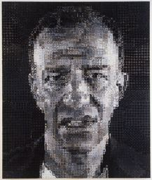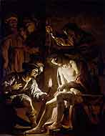 [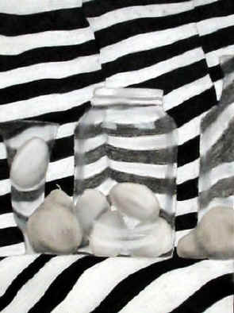](http://www.princetonol.com/groups/iad/lessons/high/images/Donnalyn-values.jpg)

**Color** - a hue or pigment

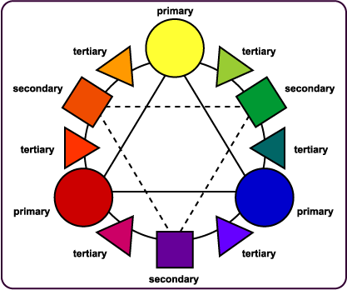 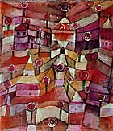 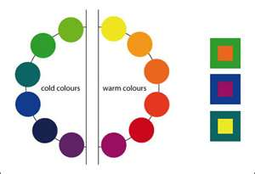

**Shape/Form**- any flat area bound by line, value, or color – **Form**: the mass of a shape

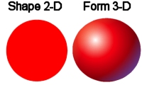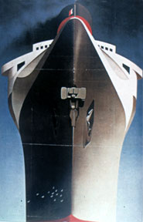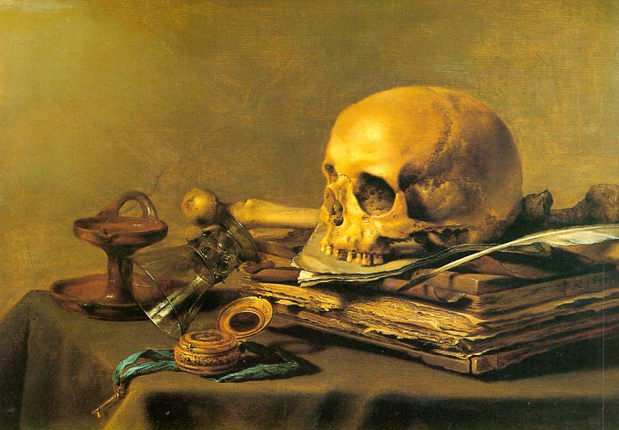

**Principles of Design**

**Unity**: the relationship between the individual parts and the whole of a composition. (Students standing side by side as closely as possible)

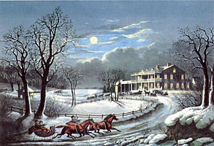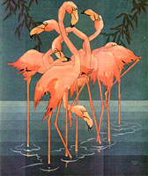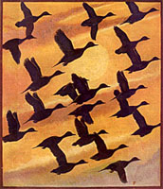

**Balance**: a feeling of equality of weight, attention, or attraction of the various elements within the composition as a means of accomplishing unity. (Two items, one in each hand…hold as long as possible)

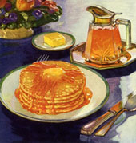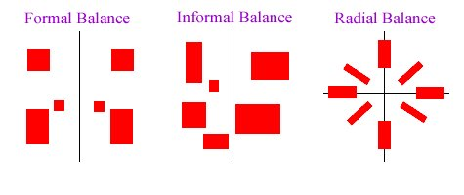 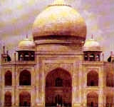

**Repetition/rhythm**: the act of repeating an element either regularly or irregularly resulting in a rhythm of the repeating elements. (Students will perform the “wave”)

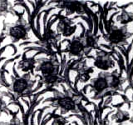 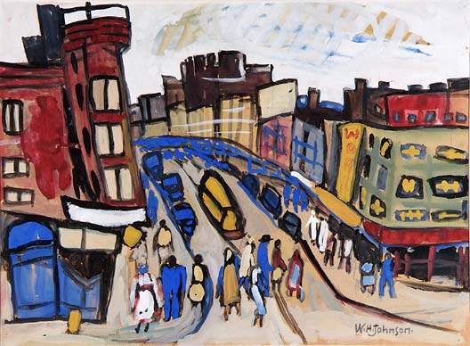 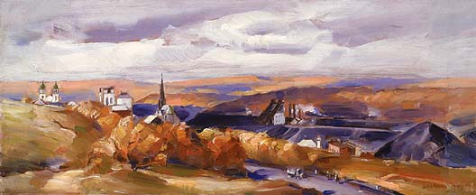

**Contrast**: the difference between elements or the opposition to various elements.

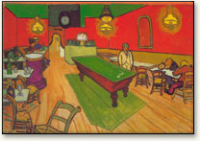[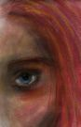](http://rds.yahoo.com/_ylt=A0WTefifSThL6tUAn3ajzbkF/SIG=12eucmlak/EXP=1262066463/**http:/www.brevpatterson.com/images/art/paper/contrast.jpg) 

**Space**: the interval or measurable distance between objects or forms (two dimensional or three dimensional)

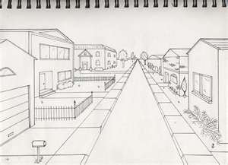 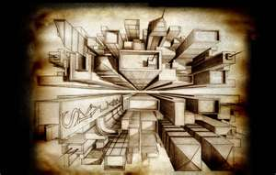 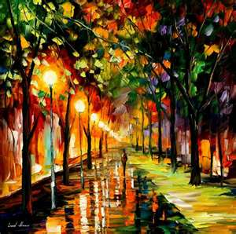

**Proportion**: the relation of two things in size, number, amount, or degree. (Comparing the tallest student to the shortest student)

 